BAI TAP CHUONG 8

NGUYEN QUANG DONG

August 27, 2020

setwd("D:/TH_RStudio")  
ch0bt10=read.table("D:/dataR/ch0bt10.txt", header=TRUE)  
ch0bt10

## Observation M1 R P GDP  
## 1 1979-1 22,175.00 11.13333 0.77947 334,800  
## 2 1979-2 22,841.00 11.16667 0.80861 336,708  
## 3 1979-3 23,461.00 11.80000 0.82649 340,096  
## 4 1979-4 23,427.00 14.18333 0.84863 341,844  
## 5 1980-1 23,811.00 14.38333 0.86693 342,776  
## 6 1980-2 23,612.33 12.98333 0.88950 342,264  
## 7 1980-3 24,543.00 10.71667 0.91553 340,716  
## 8 1980-4 25,638.66 14.53333 0.93743 347,780  
## 9 1981-1 25,316.00 17.13333 0.96523 354,836  
## 10 1981-2 25,501.33 18.56667 0.98774 359,352  
## 11 1981-3 25,382.33 21.01666 1.01314 356,152  
## 12 1981-4 24,753.00 16.61665 1.03410 353,636  
## 13 1982-1 25,094.33 15.35000 1.05743 349,568  
## 14 1982-2 25,253.66 16.04999 1.07748 345,284  
## 15 1982-3 24,936.66 14.31667 1.09666 343,028  
## 16 1982-4 25,553.00 10.88333 1.11641 340,292  
## 17 1983-1 26,755.33 9.61667 1.12303 346,072  
## 18 1983-2 27,412.00 9.31667 1.13395 353,860  
## 19 1983-3 28,403.33 9.33333 1.14721 359,544  
## 20 1983-4 28,402.33 9.55000 1.16059 362,304  
## 21 1984-1 28,715.66 10.08333 1.17117 368,280  
## 22 1984-2 28,996.33 11.45000 1.17406 376,768  
## 23 1984-3 28,479.33 12.45000 1.17795 381,016  
## 24 1984-4 28,669.00 10.76667 1.18438 385,396  
## 25 1985-1 29,018.66 10.51667 1.18990 390,240  
## 26 1985-2 29,398.66 9.66667 1.20625 391,580  
## 27 1985-3 30,203.66 9.03333 1.21492 396,384  
## 28 1985-4 31,059.33 9.01667 1.21805 405,308  
## 29 1986-1 30,745.33 11.03333 1.22408 405,680  
## 30 1986-2 30,477.66 8.73333 1.22856 408,116  
## 31 1986-3 31,563.66 8.46667 1.23916 409,160  
## 32 1986-4 32,800.66 8.40000 1.25368 409,616  
## 33 1987-1 33,958.33 7.25000 1.27117 416,484  
## 34 1987-2 35,795.66 8.30000 1.28429 422,916  
## 35 1987-3 35,878.66 9.30000 1.29599 429,980  
## 36 1987-4 36,336.00 8.70000 1.31001 436,264  
## 37 1988-1 36,480.33 8.61667 1.32325 440,592  
## 38 1988-2 37,108.66 9.13333 1.33219 446,680  
## 39 1988-3 38,423.00 10.05000 1.35065 450,328  
## 40 1988-4 38,480.66 10.83333 1.36648 453,516

ch0bt10=ts(ch0bt10, start=c(1979,1), frequency=4)  
M1=ch0bt10[,c(1)]  
plot(M1)

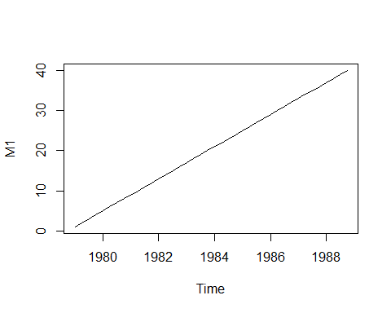

R=ch0bt10[,c(2)]  
P=ch0bt10[,c(3)]  
GDP=ch0bt10[,c(4)]  
plot(R)

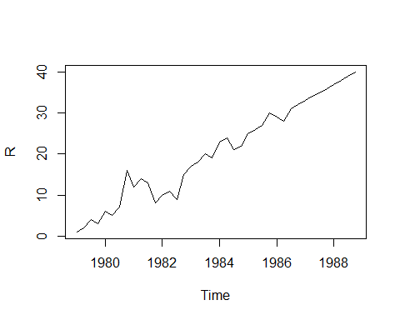

plot(P)

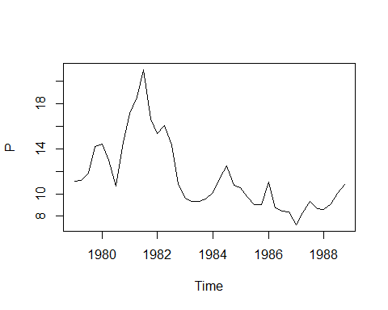

plot(GDP)

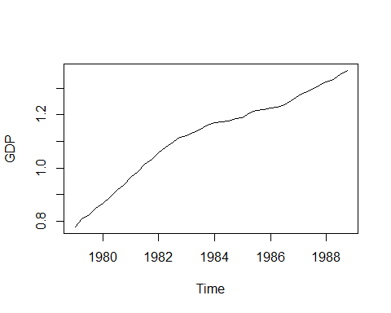

M=M1/P  
plot(M,GDP, type="l", col="red",lwd=2)

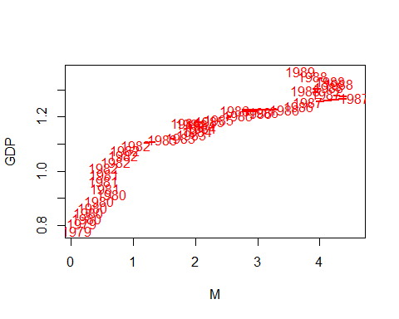

plot(R,M, col="red",lwd=2)

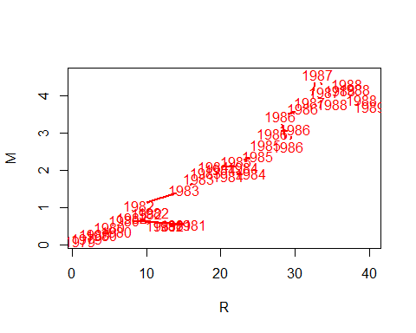

## UOC LUONG HAM CAU TIEN

# B攼㸰i toan co khoang tin cay/kiem dinh can goi cac packages sau :   
library(sandwich)  
library(car)

## Loading required package: carData

library(carData)  
library(sandwich)  
library(zoo)

##   
## Attaching package: 'zoo'

## The following objects are masked from 'package:base':  
##   
## as.Date, as.Date.numeric

# Modul "dynlm" - uoc luong khi co bien tre  
library(dynlm)  
# Hoi quy Ln(M) = b0+b1*Ln(Y)+b2*b3*Ln(R) + b4*Ln(Y(-1))  
reg=dynlm(log(M)~log(GDP)+log(R)+L(log(M),1))  
summary(reg)

##   
## Time series regression with "ts" data:  
## Start = 1979(2), End = 1988(4)  
##   
## Call:  
## dynlm(formula = log(M) ~ log(GDP) + log(R) + L(log(M), 1))  
##   
## Residuals:  
## Min 1Q Median 3Q Max   
## -0.25130 -0.09241 0.01475 0.08293 0.24104   
##   
## Coefficients:  
## Estimate Std. Error t value Pr(>|t|)   
## (Intercept) 0.7890 0.2736 2.884 0.00668 **   
## log(GDP) 1.5419 0.6430 2.398 0.02195 *   
## log(R) -0.2939 0.1041 -2.824 0.00778 **   
## L(log(M), 1) 0.8963 0.1172 7.645 5.73e-09 ***  
## ---  
## Signif. codes: 0 '***' 0.001 '**' 0.01 '*' 0.05 '.' 0.1 ' ' 1  
##   
## Residual standard error: 0.121 on 35 degrees of freedom  
## Multiple R-squared: 0.9845, Adjusted R-squared: 0.9832   
## F-statistic: 742 on 3 and 35 DF, p-value: < 2.2e-16

# Goi packages "lmtest" de thwcj hien kiem dinh:dang ham, PSSS  
library(lmtest)  
# kiem dinh dang ham, thieu bien  
resettest(reg)

##   
## RESET test  
##   
## data: reg  
## RESET = 3.3113, df1 = 2, df2 = 33, p-value = 0.04891

# kiem dinh PSSS banwg BP  
bptest(reg)

##   
## studentized Breusch-Pagan test  
##   
## data: reg  
## BP = 5.3605, df = 3, p-value = 0.1472

# Kiem dinh tu tuong qua bac 1 bang BG  
reg1=dynlm(resid(reg)~L(resid(reg)))  
summary(reg1)

##   
## Time series regression with "ts" data:  
## Start = 1979(3), End = 1988(4)  
##   
## Call:  
## dynlm(formula = resid(reg) ~ L(resid(reg)))  
##   
## Residuals:  
## Min 1Q Median 3Q Max   
## -0.252257 -0.093221 0.008918 0.074704 0.257289   
##   
## Coefficients:  
## Estimate Std. Error t value Pr(>|t|)  
## (Intercept) -0.004979 0.018648 -0.267 0.791  
## L(resid(reg)) 0.070390 0.162065 0.434 0.667  
##   
## Residual standard error: 0.1149 on 36 degrees of freedom  
## Multiple R-squared: 0.005213, Adjusted R-squared: -0.02242   
## F-statistic: 0.1886 on 1 and 36 DF, p-value: 0.6666

# ket luan?  
  
# Perform Breusch-Godfrey test for first-order serial correlation  
bgtest(reg,order=1)

##   
## Breusch-Godfrey test for serial correlation of order up to 1  
##   
## data: reg  
## LM test = 0.26243, df = 1, p-value = 0.6085

# Kiem dinh BG bac cao  
bgtest(reg1, order=4)

##   
## Breusch-Godfrey test for serial correlation of order up to 4  
##   
## data: reg1  
## LM test = 0.68755, df = 4, p-value = 0.9529

# kiem dinh TTQ bac 1 bang Durbin-Watson (DW)  
dwtest(reg)## UOC LUONG HAM CAU TIEN SAU KHI BO BIEN SO

##   
## Durbin-Watson test  
##   
## data: reg  
## DW = 1.7808, p-value = 0.1408  
## alternative hypothesis: true autocorrelation is greater than 0

# KHAC PHUC DANG HAM SAI

# Hoi quy Ln(M) = b0+b1*Ln(Y)+b2*b3*Ln(R) + b4*Ln(Y(-1)+ b4*Ln(Y(-2))  
reg2=dynlm(log(M)~log(GDP)+L(log(M),1:2))  
summary(reg2)

##   
## Time series regression with "ts" data:  
## Start = 1979(3), End = 1988(4)  
##   
## Call:  
## dynlm(formula = log(M) ~ log(GDP) + L(log(M), 1:2))  
##   
## Residuals:  
## Min 1Q Median 3Q Max   
## -0.258325 -0.096394 0.007781 0.070679 0.272518   
##   
## Coefficients:  
## Estimate Std. Error t value Pr(>|t|)   
## (Intercept) -0.008229 0.060647 -0.136 0.8929   
## log(GDP) 1.383427 0.748336 1.849 0.0732 .   
## L(log(M), 1:2)1 0.970515 0.154507 6.281 3.72e-07 ***  
## L(log(M), 1:2)2 -0.223177 0.143184 -1.559 0.1283   
## ---  
## Signif. codes: 0 '***' 0.001 '**' 0.01 '*' 0.05 '.' 0.1 ' ' 1  
##   
## Residual standard error: 0.1227 on 34 degrees of freedom  
## Multiple R-squared: 0.982, Adjusted R-squared: 0.9804   
## F-statistic: 616.9 on 3 and 34 DF, p-value: < 2.2e-16

# kiem dinh dang ham, thieu bien  
resettest(reg2)

##   
## RESET test  
##   
## data: reg2  
## RESET = 1.3447, df1 = 2, df2 = 32, p-value = 0.275

# kiem dinh PSSS banwg BP  
bptest(reg2)

##   
## studentized Breusch-Pagan test  
##   
## data: reg2  
## BP = 3.4471, df = 3, p-value = 0.3277

# Kiem dinh tu tuong qua bac 1 bang BG  
reg3=dynlm(resid(reg2)~L(resid(reg2)))  
summary(reg3)

##   
## Time series regression with "ts" data:  
## Start = 1979(4), End = 1988(4)  
##   
## Call:  
## dynlm(formula = resid(reg2) ~ L(resid(reg2)))  
##   
## Residuals:  
## Min 1Q Median 3Q Max   
## -0.257181 -0.099024 -0.000599 0.072773 0.273247   
##   
## Coefficients:  
## Estimate Std. Error t value Pr(>|t|)  
## (Intercept) -0.0009051 0.0198734 -0.046 0.964  
## L(resid(reg2)) -0.0010941 0.1711358 -0.006 0.995  
##   
## Residual standard error: 0.1208 on 35 degrees of freedom  
## Multiple R-squared: 1.168e-06, Adjusted R-squared: -0.02857   
## F-statistic: 4.087e-05 on 1 and 35 DF, p-value: 0.9949

# ket luan?  
  
# Perform Breusch-Godfrey test for first-order serial correlation  
bgtest(reg3,order=1)

##   
## Breusch-Godfrey test for serial correlation of order up to 1  
##   
## data: reg3  
## LM test = 0.50797, df = 1, p-value = 0.476

# Kiem dinh BG bac cao  
bgtest(reg3, order=4)

##   
## Breusch-Godfrey test for serial correlation of order up to 4  
##   
## data: reg3  
## LM test = 2.5927, df = 4, p-value = 0.6281